Decision Quality
This phase is designed to build a robust case for change, which informs decision makers of the potential opportunities and value for a particular customer group and enables prioritisation of resources to target that value.
Our brains aren’t wired to make good decisions, especially where situations are unique or uncertain. The way that the team leading a prediscovery will build this case for change is with a decision making framework called Decision Quality. Decision Quality requires teams to fulfil 6 elements to ensure decisions are based on quality information and sound reasoning.
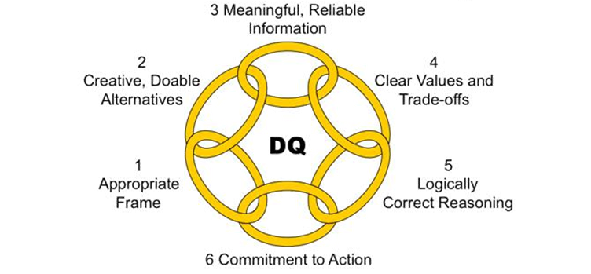Appropriate Frame – The Frame explains the opportunity the Development Team is addressing and the decision required. The Frame has three components: purpose for the decision, what is included and excluded from the scope, and the perspective applied – how the team approaches the decision and who has been engaged.
Creative Alternatives – These are a number of possible options to deliver the desired outcome. Alternatives specify ‘what we could do’.
Relevant & Reliable Information – Decisions must be based on relevant and reliable information in order to understand how each alternative will potentially influence or deliver the desired outcome.
Clear values and Trade-offs – Value describes the outcome we want – what we care about. When making a decision it is important we are aware of the trade-offs, costs and assumptions between the alternatives.
Sound Reasoning – Sound reasoning uses the basis of the decision developed in the first four elements to synthesise a clear set of conclusions to present to decision makers that will enable effective targeting of the desire value.
Commitment to Action – No decision is worthwhile if there isn’t a commitment to action. The final element of decision quality is providing decision makers with a clear picture of what they are committing to so that the requirements to create ‘real’ value is clear and results in action.
Minimum Requirement
Decision making is a comparative process, meaning decision makers must be comparing a number of ‘things’ for the activity to be considered a decision. The Team must always endeavour to create a minimum of two alternatives, and these two alternatives should be compared to the understanding of current state. This means the minimum position for any decision is three alternatives, one of which is the current state.

Decision Quality and outcomes
Decisions cannot always be made with all of the information, and there will come a point where spending additional time on an element of Decision Quality will not yield additional value for the effort required. For this reason the Team will at times, either by themselves or with the Sponsor, decide when each element has been satisfactorily completed for the decision that needs to be made.
The Team should track their delivery of each element on a scale of 0-100%, with 100% being the target level of information to inform the decision. As mentioned before this mightn’t be all the available information but should represent the point at which additional effort wouldn’t yield any greater quality than the effort or time it would take to deliver.
Appropriate Frame | 0 | 100
Creative Alternatives | 0 | 100
Reliable Information | 0 | 100
Clear Values and Trade-off’s | 0 | 100
Sound Reasoning | 0 | 100
Commitment to Action | 0 | 100

It’s important for the Team to remember that the outcome of the decision doesn’t always reflect the quality of the work done by the team or mean the decision was poor. Decisions are always based on the best information available at the time (possibilities and probabilities) and it’s important to recognise that either changes made during implementation or in the environment pre or post deployment may affect the outcome or delivery of benefits.

Applying Decision Quality
While Decision Quality will be used by the Team throughout the delivery of pre-discovery, it can be applied in discoveries, alpha and beta.

Decision Quality: Value Creation from Better Business Decisions by Carl Spetzler,‎ Hannah Winter,‎ Jennifer Meyer (2016)

